Fibonacci Series using Recursion
Aim:
To print the Fibonacci series using recursion.
Algorithm:
- Start the program.
- Define a recursive function fibonacci(n) that returns n if n <= 1, else returns fibonacci(n-1) + fibonacci(n-2).
- Take the number of terms as input.
- Use a loop to print the Fibonacci numbers.
- Stop the program.
Input:
Enter number of terms: 5
Output:
Fibonacci Series: 0 1 1 2 3
Result:
The Fibonacci series up to the given number of terms was printed successfully.

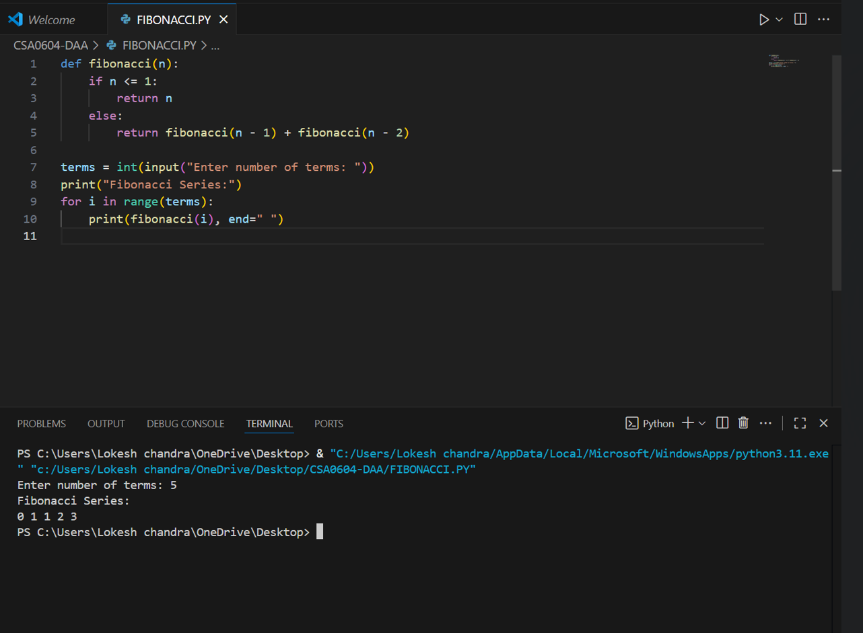

Armstrong Number Check
Aim:
To check whether a given number is an Armstrong number or not.
Algorithm:
- Start the program.
- Input a number from the user.
- Find the number of digits.
- Extract each digit and calculate the sum of its powers raised to the number of digits.
- If the sum equals the original number, it is an Armstrong number.
- Stop the program.
Input:
Enter a number: 105
Output:
105 is not an Armstrong number
Result:
The program correctly identifies Armstrong numbers.

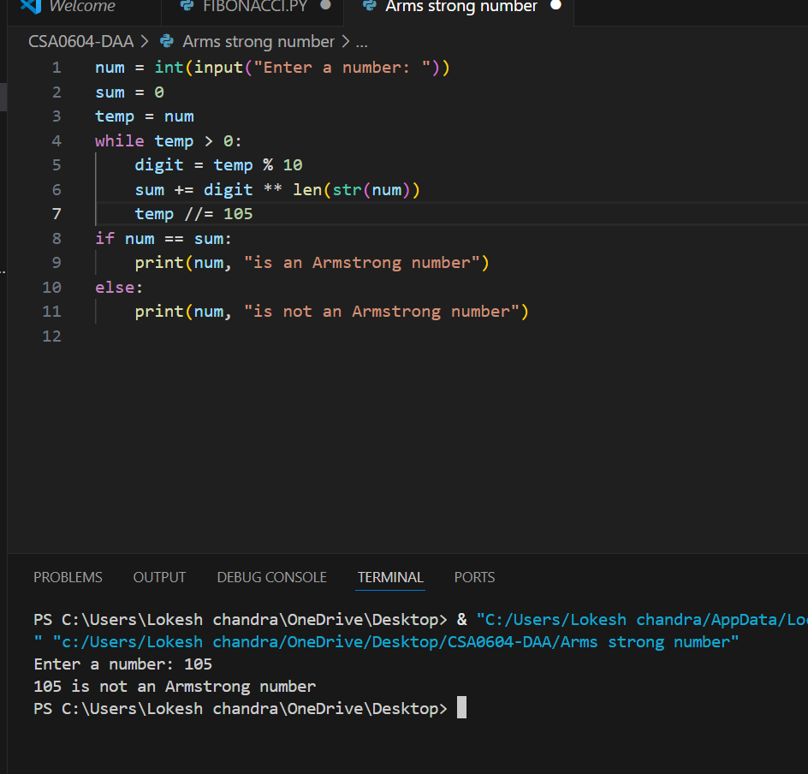

GCD of Two Numbers
Aim:
To find the Greatest Common Divisor (GCD) of two numbers using recursion.
Algorithm:
- Start the program.
- Input two numbers a and b.
- If b is 0, return a.
- Otherwise, call gcd(b, a % b).
- Display the GCD.
- Stop the program.
Input:
Enter first number: 2
Enter second number: 6
Output:
GCD of 2 and 6 is 2
Result:
The GCD of two numbers was found successfully.

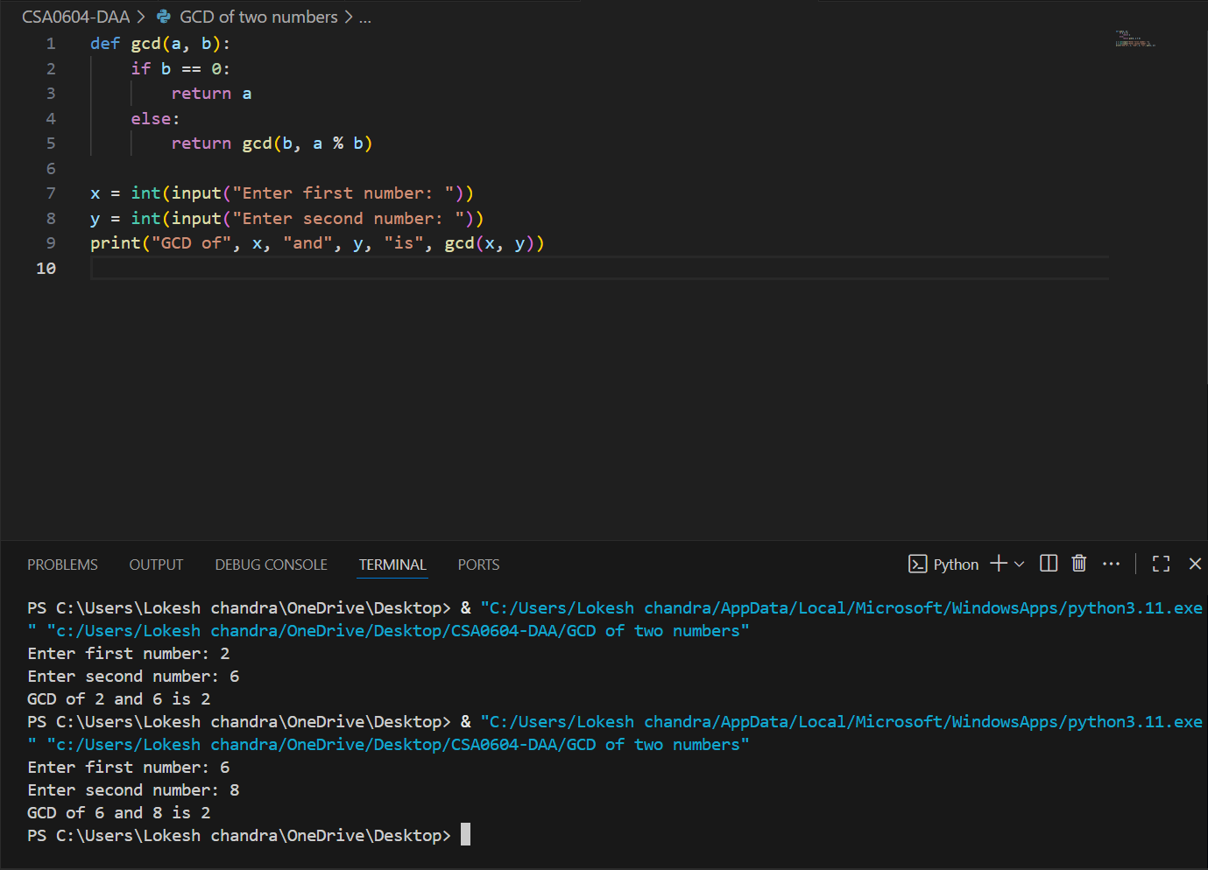

Largest Element in an Array
Aim:
To find the largest element in an array.
Algorithm:
- Start the program.
- Input elements of the array.
- Initialize largest with the first element.
- Compare each element with largest and update if a bigger value is found.
- Display the largest element.
- Stop the program.
Input:
Enter elements: 2 4 6 8 10
Output:
Largest element: 10
Result:
The program correctly finds the largest element of the array.

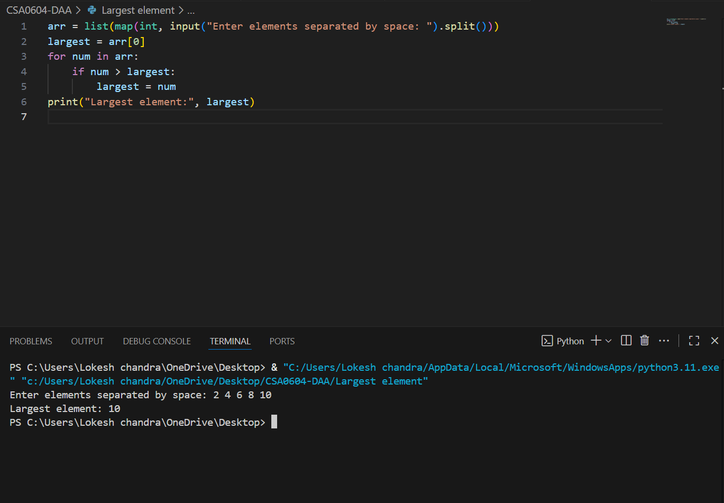

Factorial of a Number
Aim:
To find the factorial of a given number using recursion.
Algorithm:
- Start the program.
- Define a recursive function factorial(n) that returns 1 if n <= 1, else n * factorial(n - 1).
- Input a number.
- Call the function and print the result.
- Stop the program.
Input:
Enter a number: 5
Output:
Factorial of 5 is 120
Result:
The factorial of the given number was calculated successfully.

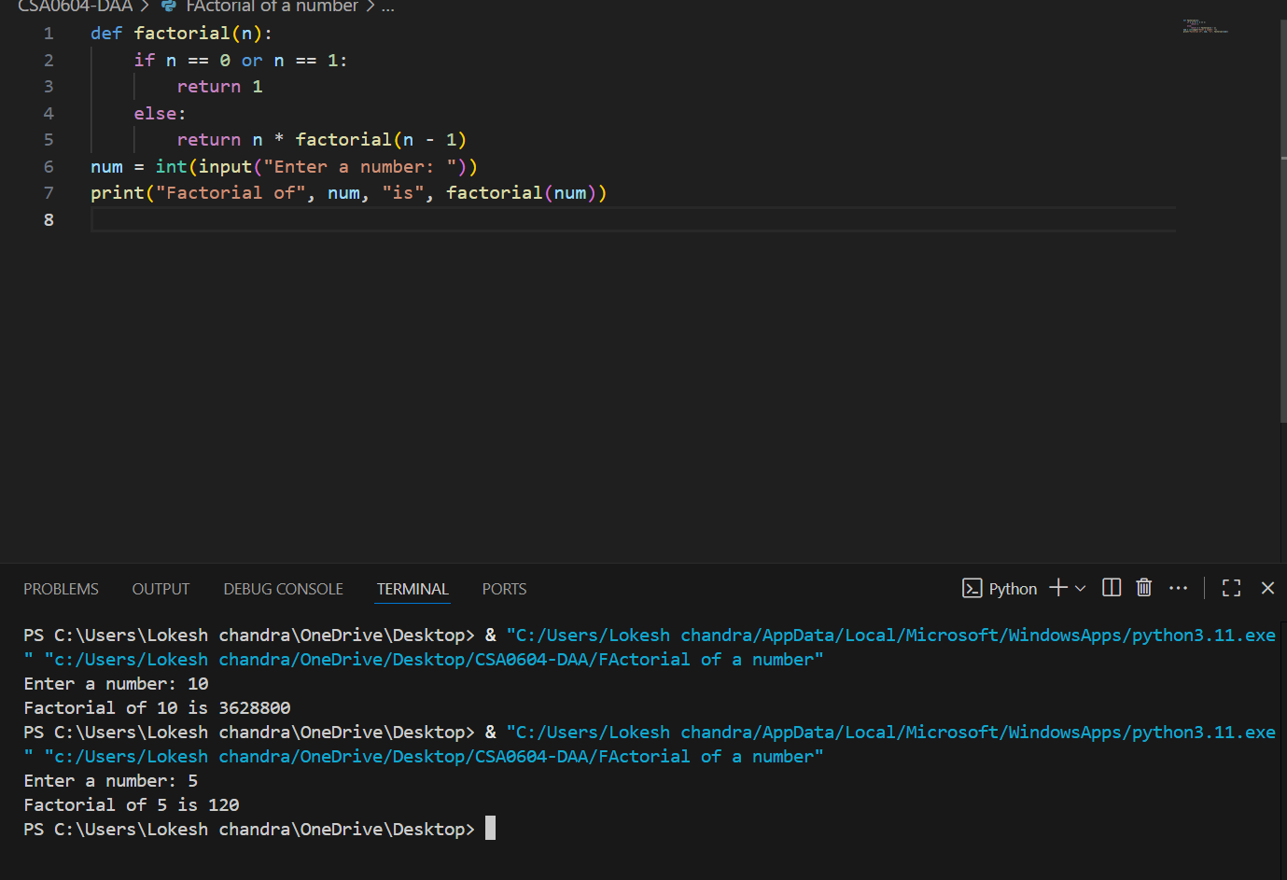

Prime Number Check
Aim:
To check whether a given number is prime or not.
Algorithm:
- Start the program.
- Input a number n.
- If n ≤ 1, it's not prime.
- Check divisibility from 2 to n/2.
- If divisible, it’s not prime; else it’s prime.
- Stop the program.
Input:
Enter a number: 13
Output:
13 is a prime number
Result:
The program correctly identifies prime numbers.

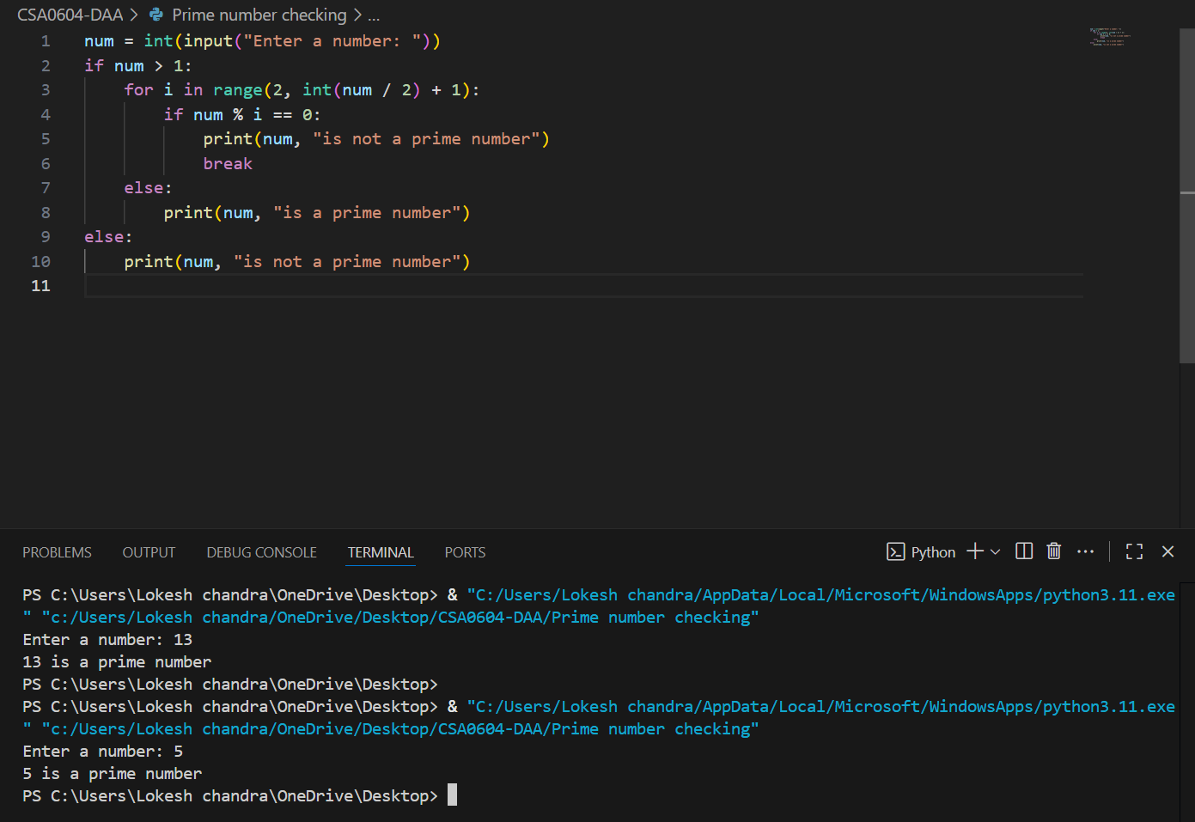

Selection Sort
Aim:
To sort an array using the selection sort algorithm.
Algorithm:
- Start the program.
- Input array elements.
- For each index i, find the smallest element in the remaining array.
- Swap the smallest element with the element at index i.
- Repeat until the array is sorted.
- Display the sorted array.
- Stop the program.
Input:
Enter numbers: 5 32 34 6 7
Output:
Sorted array: [5 ,6 ,7 ,32 ,34]
Result:
The array was sorted successfully using selection sort.

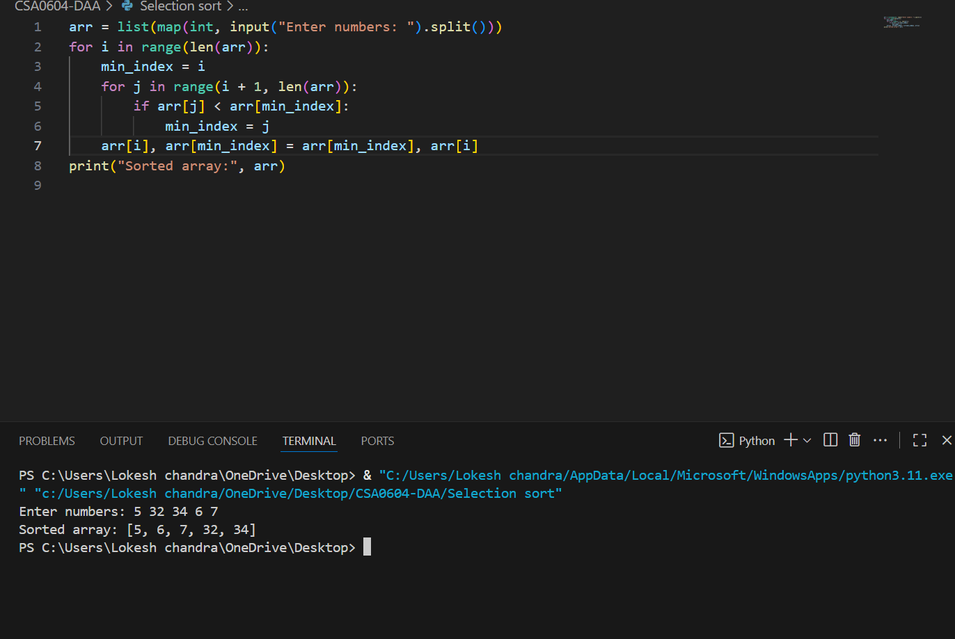

Bubble Sort
Aim:
To sort an array using the bubble sort algorithm.
Algorithm:
- Start the program.
- Input the array elements.
- Repeat (n-1) times:
  - Compare adjacent elements.
  - Swap if they are in the wrong order.
- Display the sorted array.
- Stop the program.
Input:
Enter numbers: 4 5 77 23 94 34
Output:
Sorted array: [4, 5, 23, 34 ,77 ,94 ]
Result:
The array was sorted successfully using bubble sort.

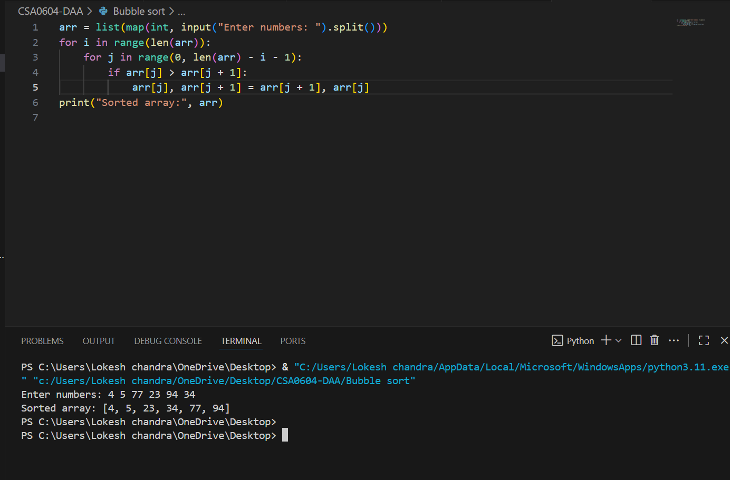

Matrix Multiplication
Aim:
To multiply two matrices.
Algorithm:
- Start the program.
- Input two matrices (2×2 or any compatible size).
- Initialize a result matrix with zeros.
- Multiply rows of the first matrix with columns of the second.
- Display the result matrix.
- Stop the program.
Input:
Matrix A = [[1, 2], [3, 4]]
Matrix B = [[5, 6], [7, 8]]
Output:
Result = [[19, 22], [43, 50]]
Result:
The two matrices were multiplied successfully.

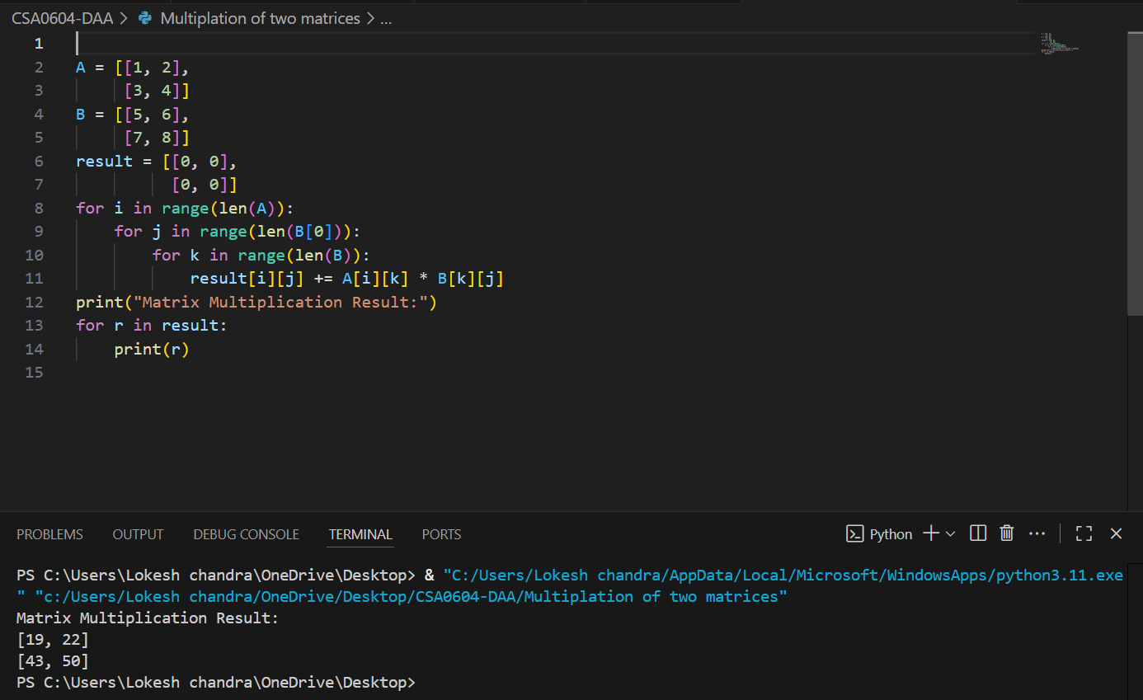

Palindrome String Check
Aim:
To check whether a given string is a palindrome or not.
Algorithm:
- Start the program.
- Input a string.
- Convert it to lowercase.
- Compare the string with its reverse.
- If both are equal, it is a palindrome.
- Stop the program.
Input:
Enter a string: madam
Output:
String is a palindrome
Result:
The program correctly checks for palindrome strings.

